Lab 2:
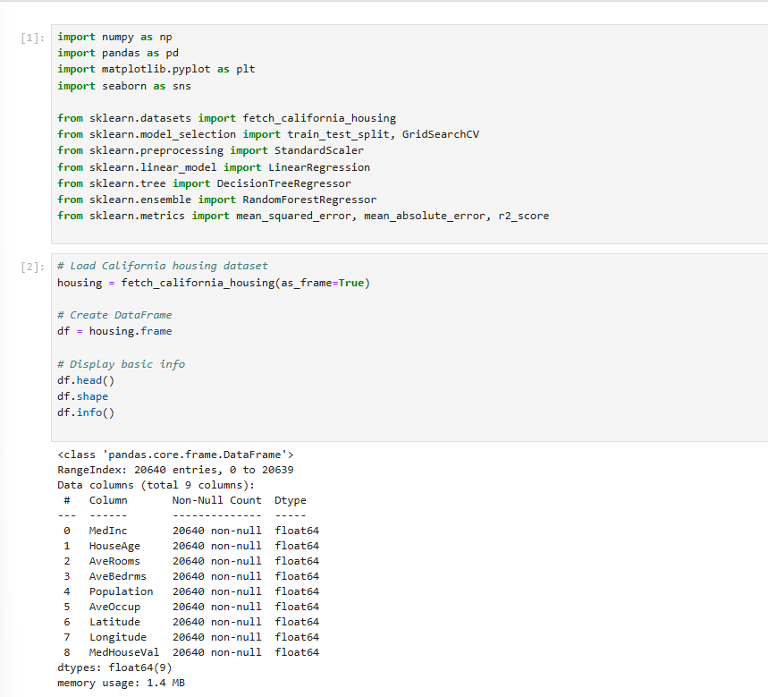
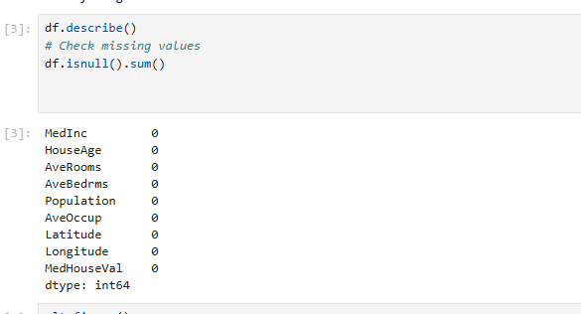
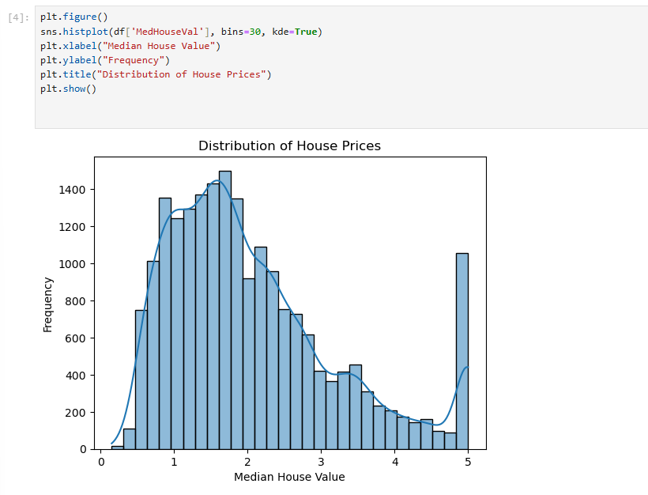
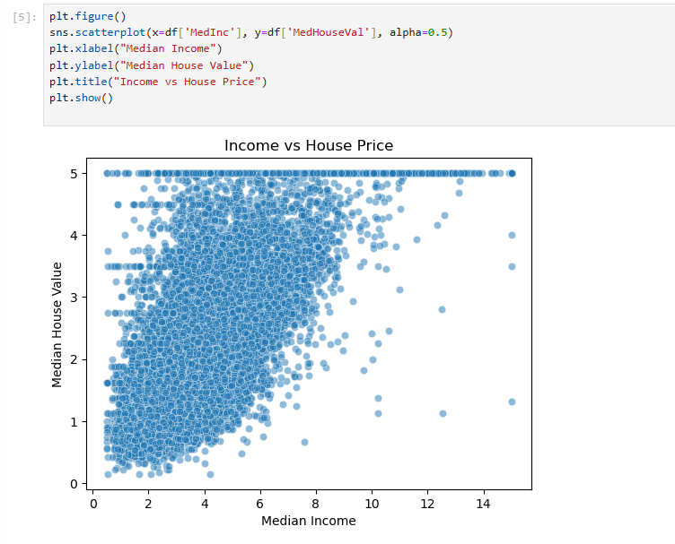

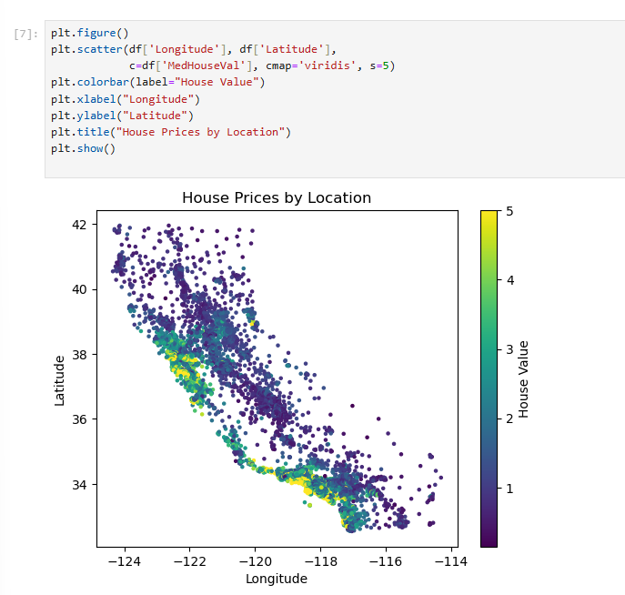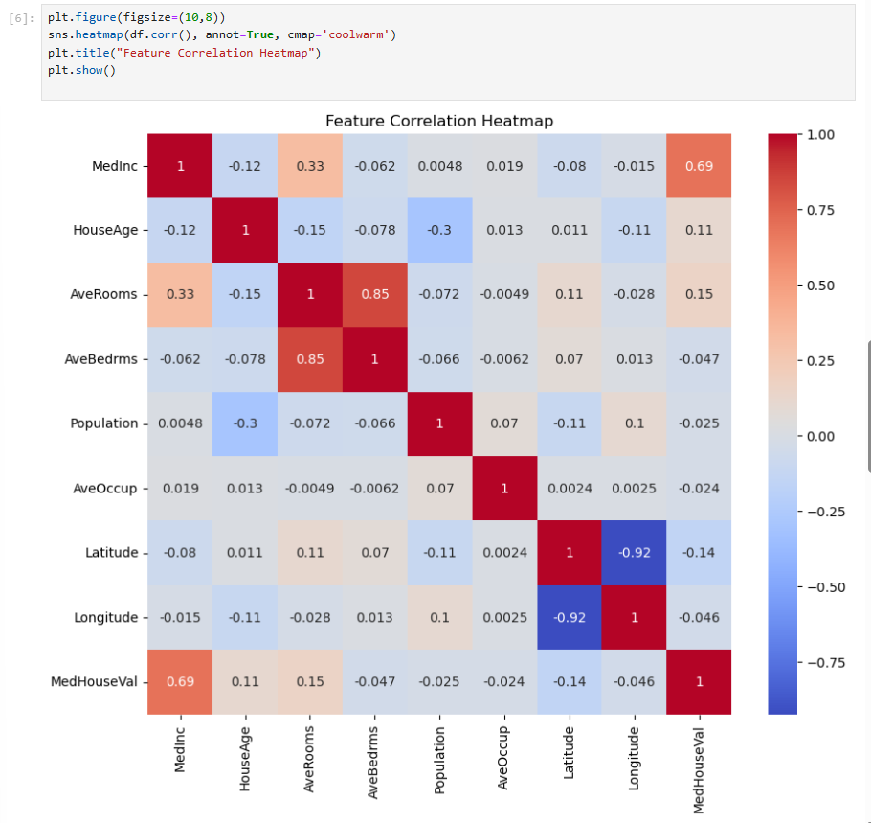

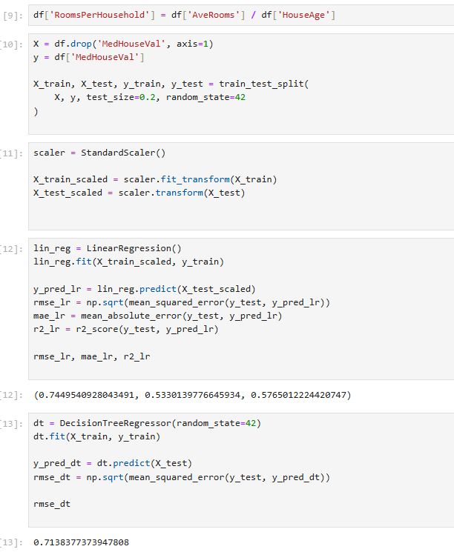
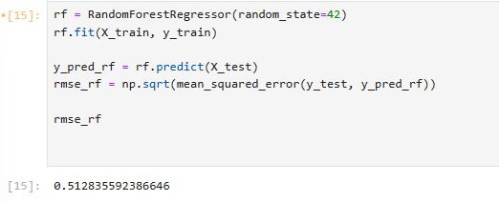

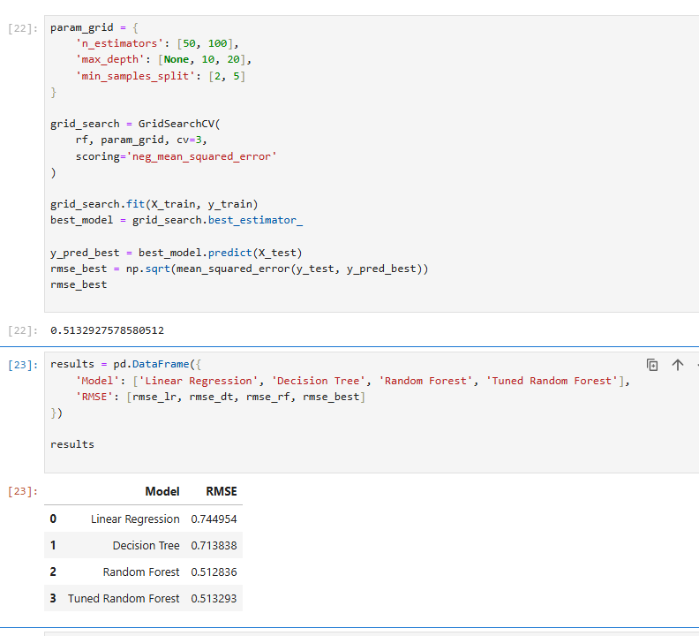

1️⃣ Which model performed best?
Random Forest performed the best, with the lowest RMSE value of 0.512836.
Since RMSE measures prediction error, lower RMSE indicates better performance.
The tuned Random Forest had a very similar RMSE (0.513293), but the basic Random Forest was slightly better in this case.

2️⃣ Why did Random Forest outperform Linear Regression?
Random Forest outperformed Linear Regression because:
- Linear Regression assumes a linear relationship between features and target.
- The California Housing dataset has non-linear relationships (as seen in the scatter plots and correlations).
- Random Forest:
  - Captures complex, non-linear patterns
  - Handles feature interactions automatically
  - Reduces overfitting by averaging multiple trees
Since house prices depend on complex interactions (income, location, rooms, etc.), Random Forest models them better than a simple linear model.

3️⃣ How did tuning improve performance?
Hyperparameter tuning attempts to:
- Optimize number of trees (n_estimators)
- Control tree depth (max_depth)
- Adjust splitting criteria (min_samples_split)
In your case:
- The tuned model performed almost the same as the default Random Forest.
- This suggests the default parameters were already close to optimal.
- Tuning did not significantly improve performance because:
  - The dataset is relatively clean
  - Random Forest is already robust
  - The parameter grid was limited
So tuning helped confirm the model configuration rather than dramatically improving it.

4️⃣ What additional data could further improve predictions?
Prediction accuracy could improve with:
- 📍 More detailed location data
  - Distance to city center
  - School ratings
  - Crime rate
  - Nearby amenities
- 🏠 Property-specific details
  - House size in square feet
  - Number of bathrooms
  - Renovation history
  - Property condition
- 📈 Economic factors
  - Interest rates
  - Employment rates
  - Market trends
- 🕒 Time-based data
  - Year of sale
  - Seasonal trends
More relevant features → better model learning → lower RMSE.

